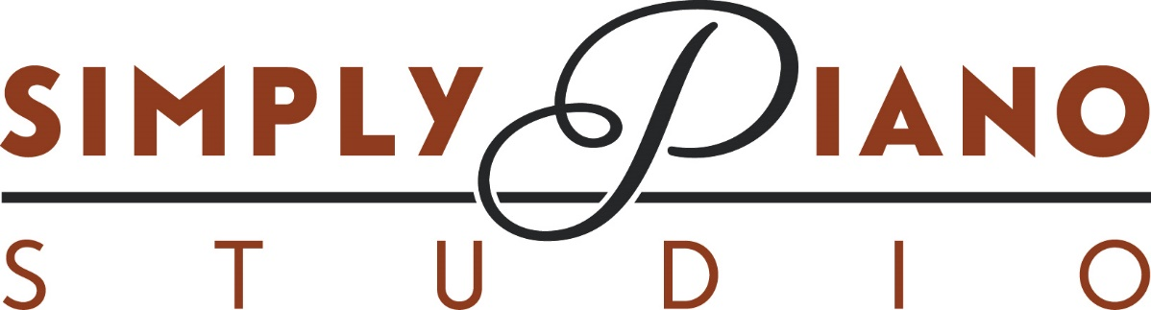

3 month package: 12 sessions- an additional 5% off

60 minutes: $336.30/mnth
45 minutes: $252.22/mnth
30 minutes: $168.15/mnth

6 month Package: 22 sessions – an additional 10% off

60 minutes: $292.05/mnth
45 minutes: $219.03/mnth
30 minutes: $146.02/mnth

10 month package: 37 sessions – an additional 15% off

60 minutes: $278.33/mnth
45 minutes $208.74/mnth
30 minutes: $139.16/mnth

Month to Month:

Base rate is $88.50/hr and this breakdown is based on a 4week month

60 minutes: $354.00/mnth
45 minutes: $265.50/mnth
30 minutes: $177.00/mnth

